OUALI Yanis

SIMOENS Thomas

ENRIQUEZ Dan

Part 3 - Econometrics Project

Introduction

Since daily data collection corresponds more to "short time windows around the events [...] unanticipated, and not confounded by other events" (see Event Study Methodology), we preferred to change our data collection frequency to weekly intensity. Indeed, our study is medium-term and focuses on an event whose effects are felt before the event (via surveys in particular) as well as after. This change is made in accordance with the feedback from part 1 of the project.

Summary of the event under study,

Summary of the portfolio description, and its relation to the event

The purpose of the project was to study the reaction of the stock markets to the election of a new President. We therefore thought it wise to choose the election of Donald Trump on November 8, 2016 against Hillary Clinton. This choice seemed relevant to us insofar as, on the one hand, his victory was unexpected because the polls announced that he would lose and, on the other hand, his accession to power marked the transition from a Democrat President (Barack Obama) to a Republican President.

It was therefore intriguing to study, beyond the immediate reaction of the financial markets to the announcement of the results, whether they had really been influenced by the outcome of the election. For this reason, our study covers an interval ranging from six months before the election date to six months after.

To highlight the consequences of our event, we have selected various stocks from the banking, energy, construction, pharmaceutical and technology sectors to build our portfolio. The portfolio consists of five stocks: Goldman Sachs, CVS Health, Caterpillar, Chevron and China Mobile. Our benchmark index, which will be tracked against our assets, is the NYSE Composite, the flagship index of the New York Stock Exchange. Since all of our shares are listed on it, it makes sense for us to rely on it.

Our intuition was that our equity portfolio would react positively overall to the 2016 U.S. presidential election. Indeed, we assumed that the respective sectors in which the selected companies operate had prepared themselves for a Hillary Clinton victory, with their market capitalization declining accordingly (with the exception of the technology sector, for geopolitical reasons).

Then, in reaction to Trump's unexpected victory, we hypothesized a fairly significant rise in stock prices, as companies looked to their future prospects more serenely. Unlike Clinton's program, Trump did not include any controls on drug prices, which is a logical fit for the pharmaceutical industry leader CVS Health. Also, the infrastructure recovery plan promised by candidate Trump has enough to delight the manufacturer Caterpillar. The climate-skeptical stance taken by the president-elect may reassure the giant oil company Chevron, whose highly polluting activity is based on the exploitation and distribution of fossil fuels. The phone operator China Mobile serves as an exception in the composition of our portfolio: based in China, its possible development in the United States may be compromised by the protectionist measures imposed by Donald Trump.

It would now be a matter of concretely testing the effect of the election on our portfolio.

Following a study conducted in the second phase of the project, we concluded that in order to achieve a portfolio with minimal variance, we must diversify the portfolio to include 1.4% Caterpillar shares, 29.4% percent China Mobile shares, 28% Chevron shares, 34% Goldman Sachs shares and 7.2% CVS Health shares.

Before arriving at this result, for practical reasons, we arbitrarily assigned the following weights to our shares: 50% for Caterpillar, 20% for China Mobile, 20% for Chevron, 5% for Goldman Sachs, and 5% for CVS Health as well.

This opposition will be the guideline of our analysis: in each event study, we will compare the results obtained in the case of a portfolio composition calculated as optimal, and in the case of an allocation set arbitrarily. The aim is therefore to study the role of weights in our portfolio.

Reaction of portfolio assets to the event

Remember that in an election, we have other sources of information than the markets. Before elections, for example, polls play a role because they anticipate a winner. The market therefore interprets this information even before the event takes place. This is why, graphically, we see a reaction before the event as well as after.

The first event study is the reaction of the portfolio assets to the event. Based on a weighting arbitrarily fixed for each share, the result obtained is this one.

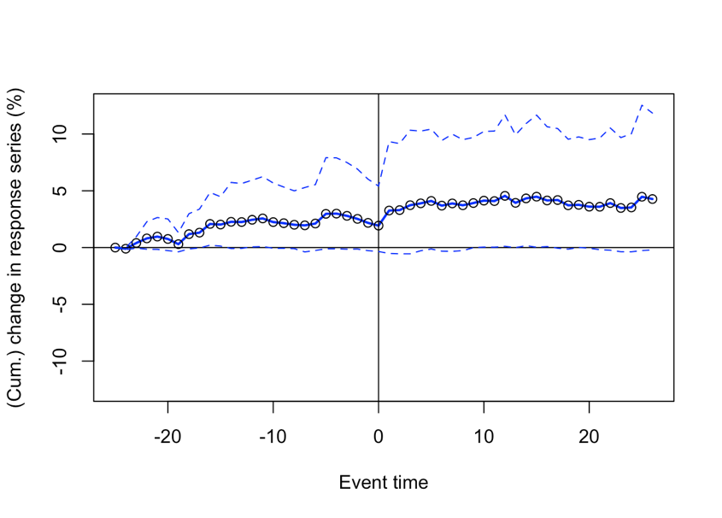

Chart 1: Portfolio reaction (with arbitrary composition) to the event.

Initially, there was a sharp slowdown in cumulative returns around the eighteenth week before the election. Then, we clearly distinguish three phases. About ten weeks before the election, our portfolio experienced a slight slowdown in the evolution of its returns, before recovering five weeks before the event. Then it slowed again three weeks before, until election day, which marked a low point. In the weeks following Donald Trump's election, the portfolio's performance accelerated before stabilizing at around 4%.

The second event study concerns the reaction of the assets in the portfolio to the event, with the difference that here the weight of each firm in the composition of the portfolio is set so as to minimize its total variance.

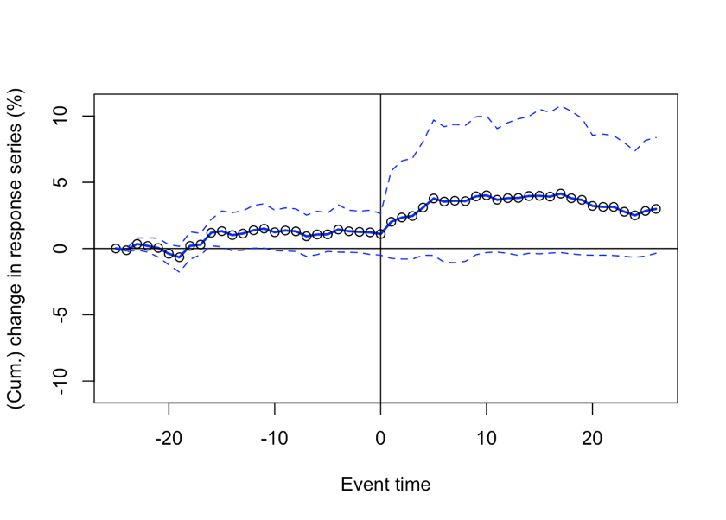

Chart 4: Portfolio reaction (with minimum variance) to the event.

Once again, eighteen weeks before the election, we are seeing a fairly significant slowdown in the average value of our financial assets. In the run-up to the election, on the other hand, we note that the cumulative return on this portfolio has stabilized at around 2%. Moreover, just after the event, it accelerated to about 5%.

Overall, this portfolio follows the same trends as the previous one. However, weighting by the optimal weights allows some subtleties to be drawn. For example, with optimal weighting, the weight of China Mobile share is greater than with arbitrary composition. This difference can potentially explain the amplification of the portfolio's decline in value around the eighteenth week before the event in Chart 4, compared to Chart 1. Factually, this decline corresponds to the period when Donald Trump and Hillary Clinton were "neck and neck" in the surveys.

Similarly, on Election Day, when the markets closed, the return on the optimal portfolio was lower than the return on the arbitrary portfolio, again indicating that China Mobile's reaction caused the portfolio to decline.

Reaction of the assets to the market portfolio

The aim is to relate the portfolio's reaction to that of the market (in this case that of our benchmark: the NYSE Composite).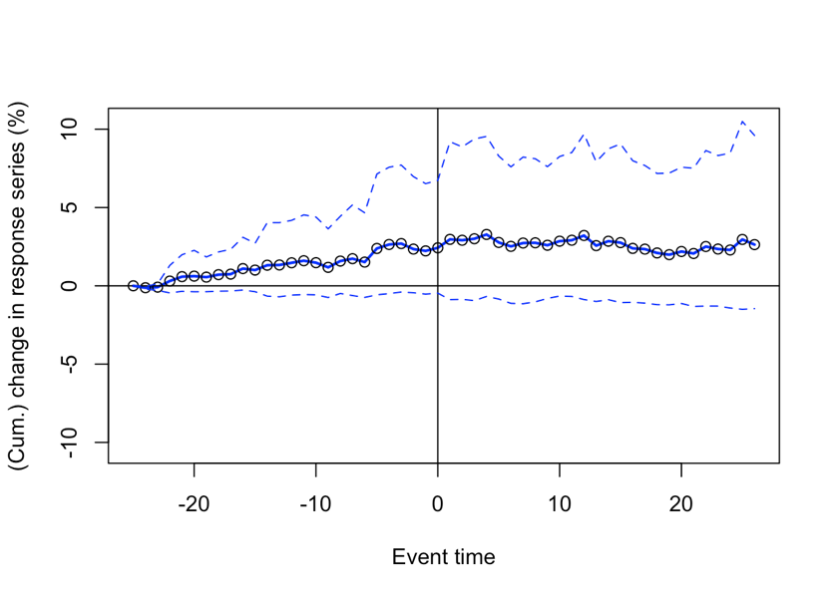

Chart 2: Portfolio reaction (with arbitrary composition) to the event, relatively to the market.

The first piece of information we draw from this graph is the outperformance of our portfolio compared to the market (here represented by the NYSE Composite Index). In fact, over the entire period studied, the weighted return of the portfolio is higher than that of the market. This corresponds to the conclusion of the study carried out in step 2: as the portfolio's beta is greater than 1, it amplifies the variations in the index.

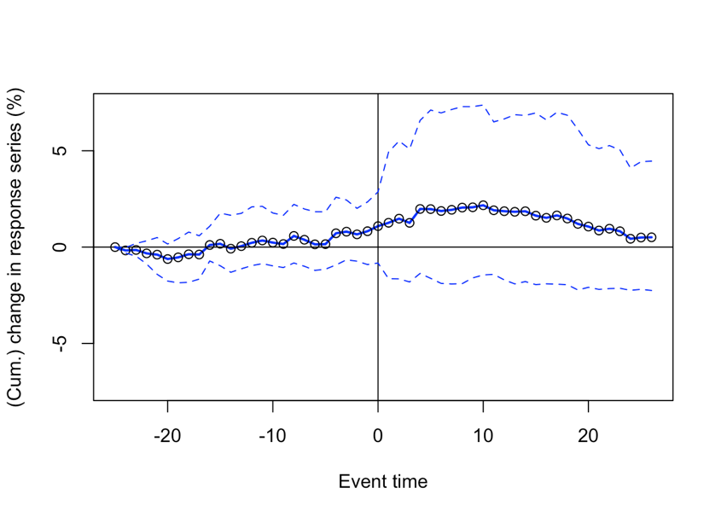

Chart 5: Portfolio reaction (with minimum variance) to the event, relatively to the market.

By optimally weighting our equities, we reach the same conclusion. However, here again, the results are lower than those obtained in the previous case. We even observe, around the eighteenth week before the election, a short period during which the portfolio performs less well than the market. At the end of the observation period, returns seem to get closer and closer.

III - Portfolio reaction to the event assuming a correlation coefficient of 1

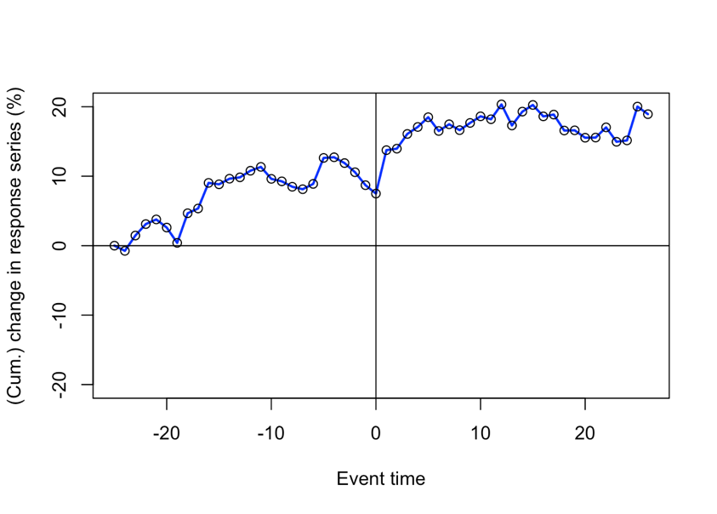

Chart 3: Portfolio reaction (with arbitrary composition) to the event, assuming a correlation coefficient of 1.

This portfolio, similar to the portfolio chosen previously, is composed of the same assets weighted in the same way, i.e. 50% for Caterpillar, 20% for China Mobile, 20% for Chevron, 5% for Goldman Sachs and 5% also for CVS health.

However, as explained in the file "Differences between event study 1 and 3", the portfolio has the specificity of having a correlation between the assets equal to 1. This is the highest possible value of the correlation coefficient. This means that, empirically, when the value of Caterpillar's assets has increased by x percent, then all other assets have also increased by x percent.

This is a very extreme assumption which implies that this portfolio has the most volatile behavior possible with the previously chosen weightings. Thus, for a cumulative return of 0.96% at the peak 21 weeks before the event (this is the 5th point from the left) with the first portfolio, we observe a cumulative return of 3.1% for the volatile portfolio. Looking at the week just after the event, we see that in the first case the cumulative returns jump from 1.93% to 3.26%. On the volatile portfolio side, we see a jump from 7.50% to 13.75%!

The latter being very volatile, it "fully" captures the effect of the event. In this case, this is the biggest jump over the 52-week period we have chosen.

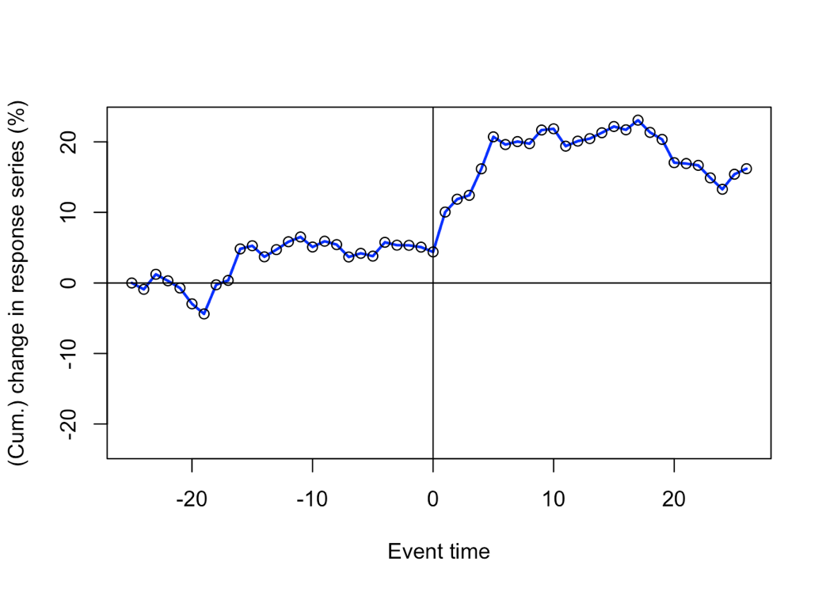

Chart 6: Portfolio reaction (with minimum variance) to the event, assuming a correlation coefficient of 1.

Now, let's look at the same volatile portfolio with the minimum variance weights found in the second part of the project. The weights are as follows: 1.4% for Caterpillar, 29.4% for China Mobile, 28% for Chevron, 34% for Goldman Sachs and 7.2% for CVS Health. It does not really make sense to look at this graph because the correlation of the assets in this portfolio has a value of 1, but we found the weights by minimizing the variance, hence the correlations.

However, this volatile portfolio can still be compared to the portfolio composed of the minimum variance weights from the third event study. We have shown with the previous example that the volatile portfolio shows higher cumulative returns when positive and it turns out that it shows lower cumulative returns when negative.

As an example, if we look at the 19th week before the event, where the cumulative returns reach a floor, the non-volatile portfolio shows a value of -0.65% compared to -2.96% for the volatile portfolio.

Once again, we see that these portfolios are actually more volatile, in both positive and negative cumulative returns because they "fully capture the market variation", which is due to the full correlation between the assets!

Conclusion

Finally, we can draw two conclusions from this event study. On the one hand, the hypothesis of a positive reaction of our portfolio to Donald Trump's surprise victory, which we had formulated in the first part of the project, proved to be correct. The diversification strategy we adopted allowed us to hedge against a potential decline, also allowing us to outperform the market.

On the other hand, our mistake was to include the China Mobile share, which has been constantly pulling down its returns, especially in the portfolio with minimal variance because it has a greater relative weight in it. We therefore realized that the composition of the portfolio that gave the lowest variance was not the one that gave the highest returns.